 **Universidad Tecnológica de Aguascalientes**

**ING. EN SISTEMAS Y DESARROLLO DE SOFTWARE**

***Actividad***: Tarea I - Unidad I - Conceptos y aplicaciones de git

***Nombre del Alumno:***

*Oscar Renato García Reséndiz*

***Nombre del(a) Profesor(a):***

*Alberto Campos Hernández*

***Materia:*** *Desarrollo Web Profesional*

***Fecha de entrega:*** *13/05/2022*

Realizar una investigación de git que cubra los siguientes conceptos. Poner una explicación con TUS PROPIAS PALABRAS y un EJEMPLO PRÁCTICO. El contenido de la investigación deberá ser en inglés. Si quieren tener un poco mas de contexto de todos los temas puede ver este curso exprés que impartí hace algunos cuatrimestres. https://www.youtube.com/watch?v=vEoFV9GKOb8

La actividad deberá ser entregada en formato PDF con la siguiente nomenclatura APELLIDO_APELLIDO_NOMBRE_ACTIVIDAD1.PDF

Deberá contener una portada institucional y formato profesional en el contenido de su trabajo.

En caso de encontrar trabajos iguales, todos los involucrados tendrán 0 de calificación en la actividad y perderán 2 puntos de la parte de SER.

***Git***

Git is the most widely used modern version control system in the world. Git is a mature and actively maintained open source project that was originally developed by Linus Torvalds, the famous creator of the Linux operating system kernel, in 2005.

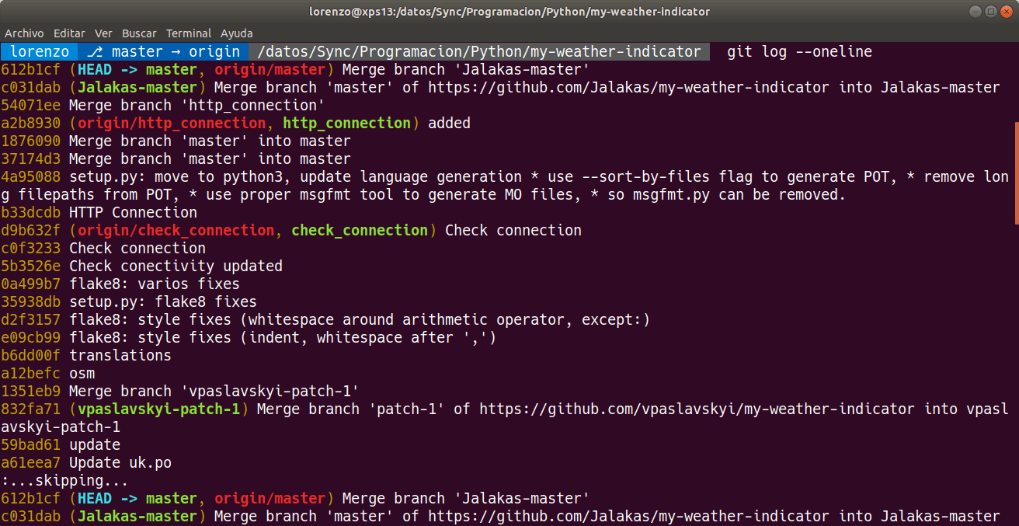

***Github***

GitHub offers cloud repository hosting service, makes it easy for individuals and teams to use Git as version control and collaboration.

GitHub's interface is quite easy to use for those who want to take advantage of Git

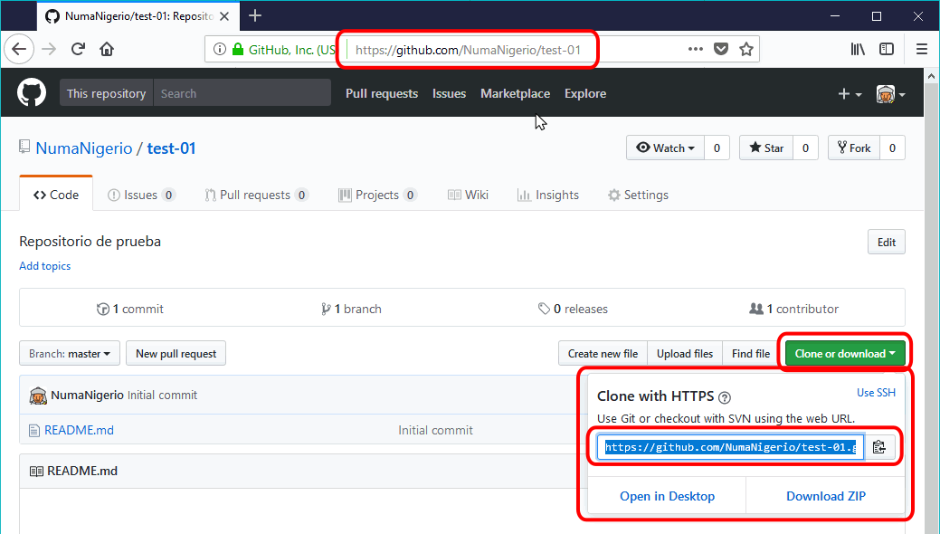

***Repositorie***

A digital or virtual repository is a website where digital information from companies or institutions is stored; the stored files can be accessed by those allowed by the institution or the administrator.



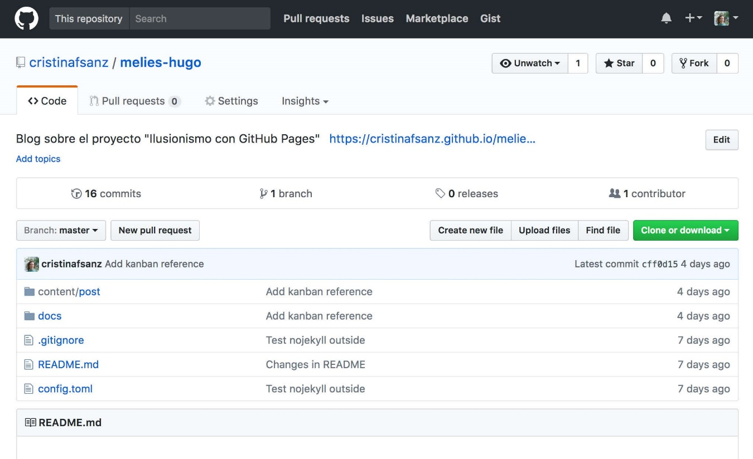

***git flow***

Git-flow is a set of extensions that save us a lot of work when executing all these commands, simplifying the management of our repository branches.

Gitflow is an alternative Git branching model that uses function branches and multiple parent branches.

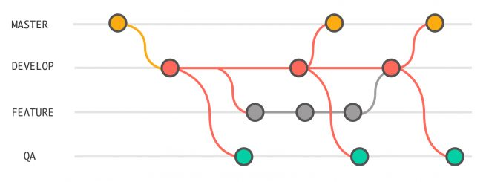

***local / stagging / remote áreas***

It's a file in your Git directory, it contains what information will be in the next commit. It is the index. The basic workflow in Git is something like You modify files in your working directory.

***status***

The git status command shows us the status of the working directory and the staging environment area. Likewise, it helps us to see the changes that have been prepared, those that have not and the files in which Git will not perform the continuation.

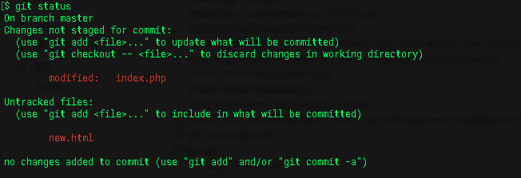

***Add***

The git add command is very useful because it adds a change from the working directory to the staging environment, this tells Git that you want to include updates to a file on the next commit.

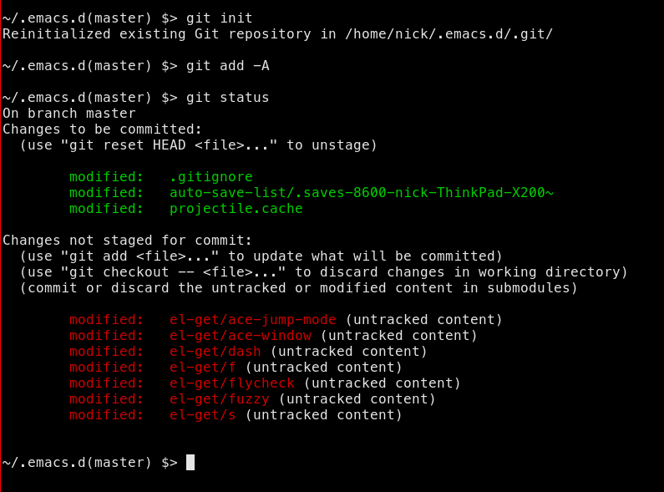

***Log***

The git log command serves as a basic Git tool for exploring repository history. This command is used when you need to find a specific version of a project or know what changes will be introduced by the in a feature branch.

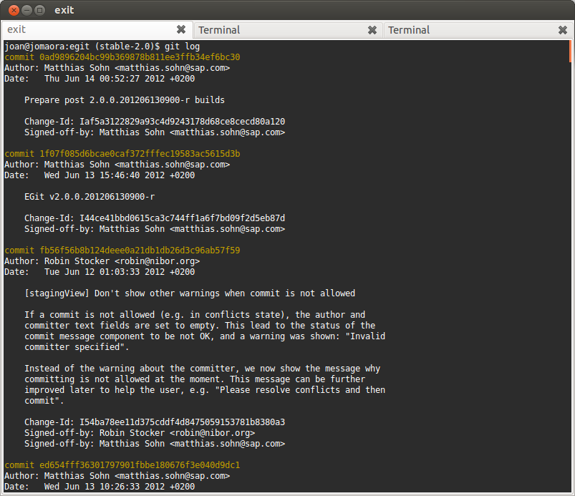

***Commit***

The git commit command will save all changes made to the application or code, along with a brief description of the user, in a Commit to the local repository.

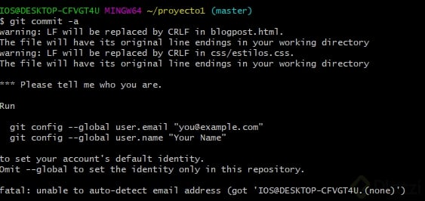

***Pull***

The git pull command is used to pull and download content from a remote repository and instantly update the local repository to display that content.

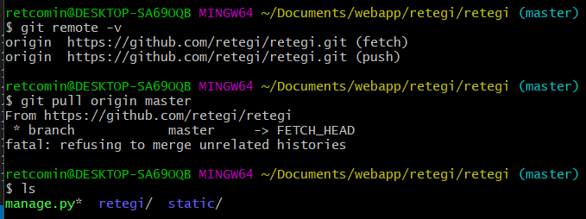

***Push***

The git push command is used to push the content of the local repository to a remote repository. Pushing serves as the way to transfer commits from your local repository to a remote repository.

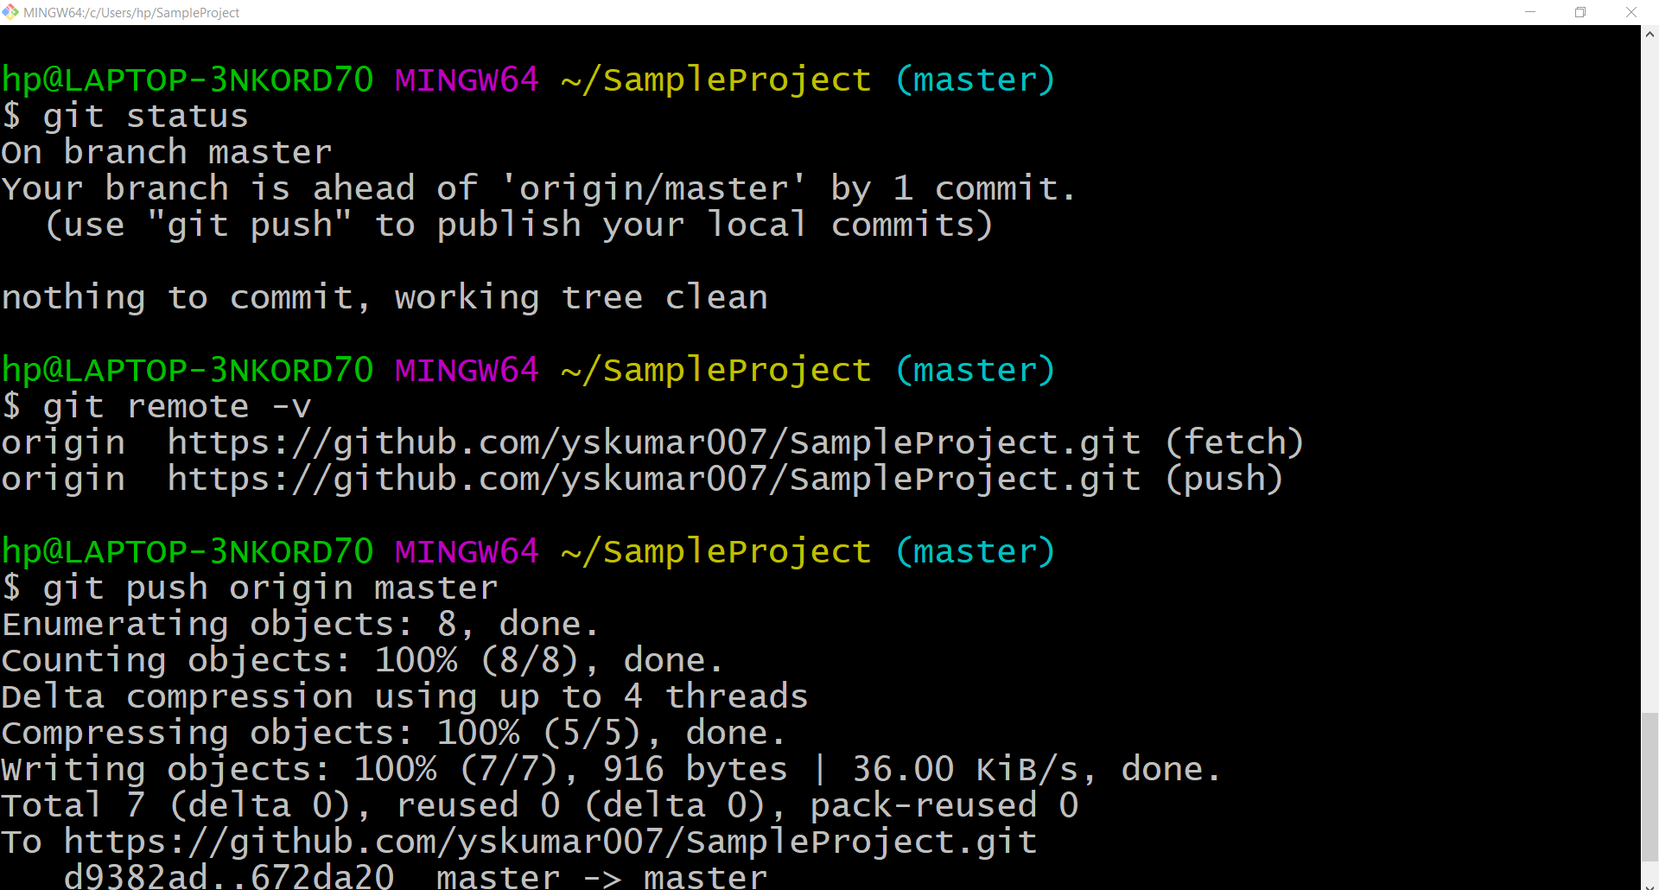

***pull request***

Pull requests allow tasks to be carried out in an orderly manner in the development stage, in addition to also creating proposals or changes that can be later integrated into said project.

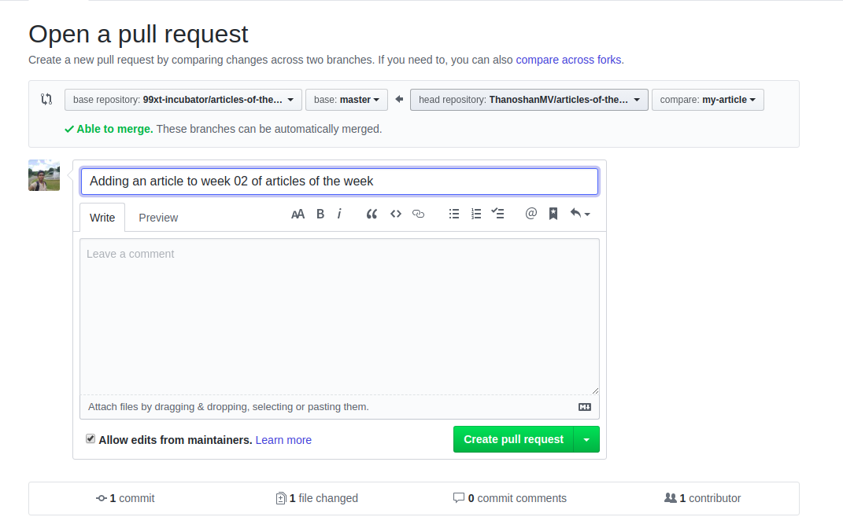

***Merge***

The git merge command serves us or allows us to take all the independent lines of development created by git branch and integrate them into a single branch.

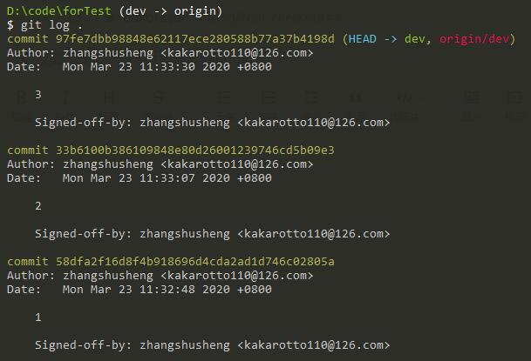

***Branch***

The git branch command allows you to create, list, and remove branches, as well as rename them.

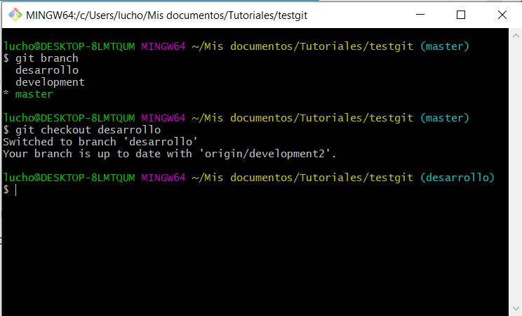

***Rebase***

It consists of changing the base of your branch from one commit to another, making it appear that you created the branch from a different one.

